Agenda-To get the details of the Operator based on the info on DB

Take one collect info step and add your properties and then go for the properties creation and in the operator ID and then get the details

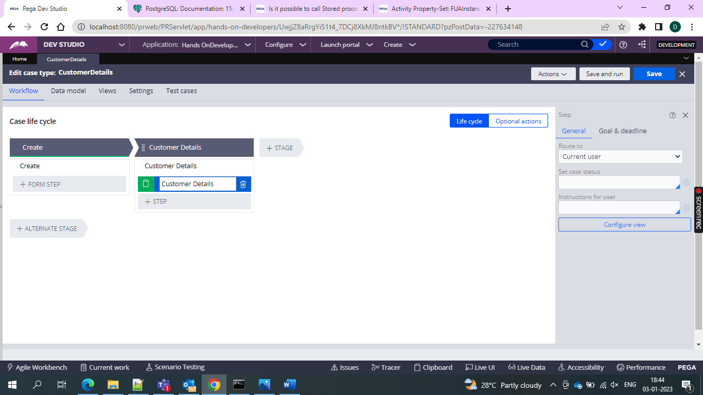

First give all the things in the operator ID

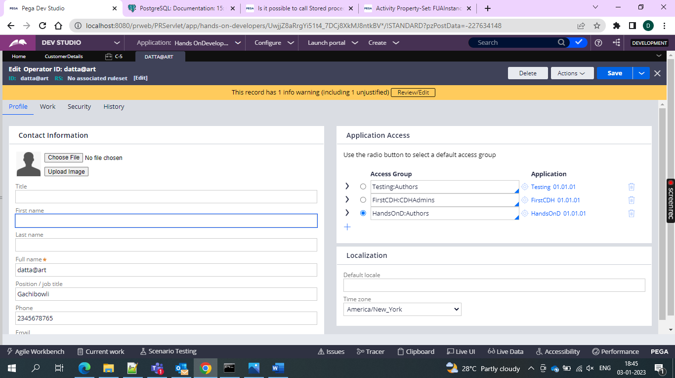

Then go for the section and then configure the usage in section and then give all the properties in section and then go for the setting of the message in the DT

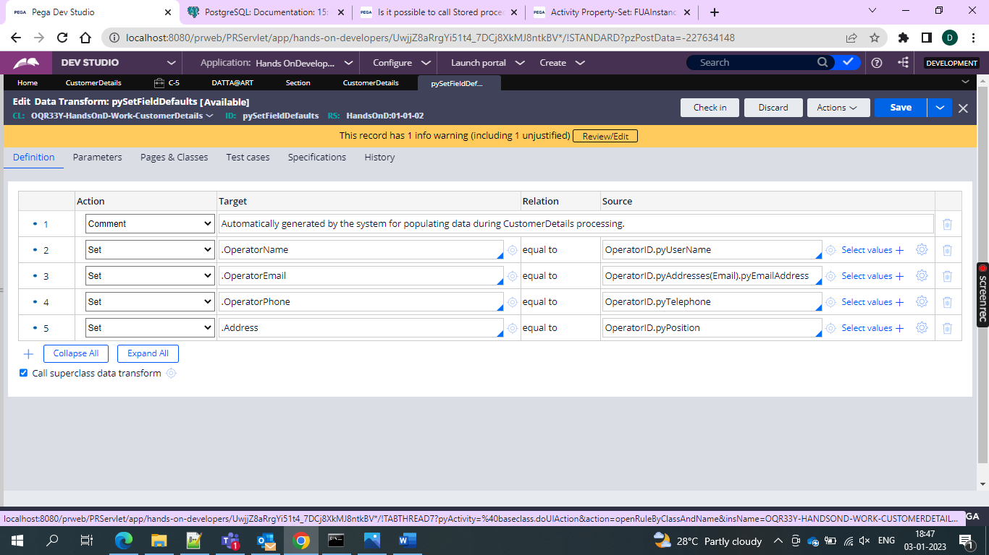

Configure the DT to map the data with the properties

And when operator logs in and see the case

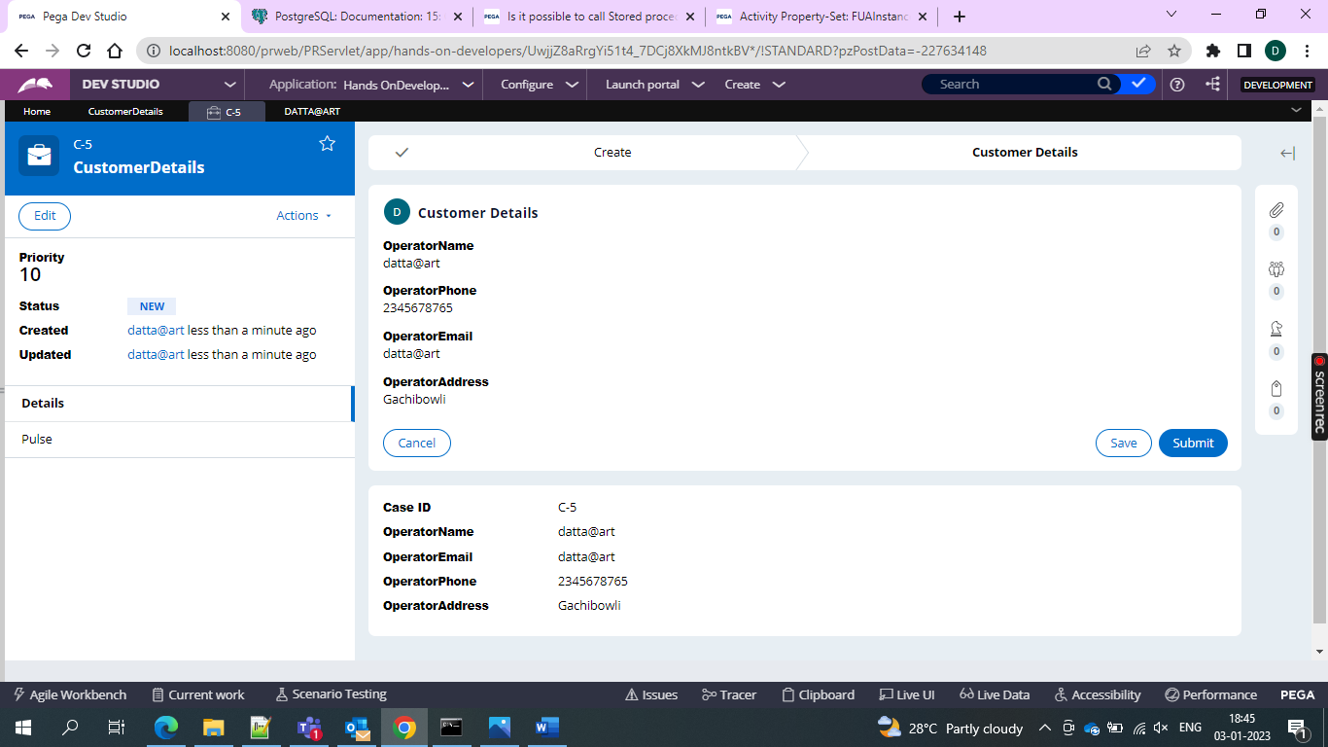

Hence all the properties are copied to the case.